Call to worship
Order of Online Worship for June 13. We will meet online for as long as people want to stay on at 10 am. The link will be posted on the website. The sanctuary is presently closed for in-person worship.

St. Andrew’s Hespeler
Presbyterian Church
June 13th, 2021
3rd Sunday after Pentecost

St. Andrew’s Hespeler Presbyterian Church
73 Queen Street East,
Cambridge, ON N3C 2A9
519-658-2652
Rev. Scott McAndless: smcandless@standrewshespeler.ca
Email: office@standrewshespeler.ca
Prayer Requests: prayerchain@standrewshespeler.ca
Website: www.standrewshespeler.ca
Office Hours:
Monday, Wednesday, Friday 9am-12pm
L: It is good to give God thanks, to sing praises to the Most High!
P: We will sing for joy to God who has made us glad.
L: Let us declare God’s steadfast love in the morning,
P: and God’s faithfulness by night.
L: So come to worship God with thankful, joyful hearts!
P: Let us praise God’s holy name together.
Prayer of Approach and Confession
L: Living God, from you comes vitality, love and joy. Your peace is our companion, your love is our strength, your Son is our hope. In even our darkest moments, your presence brings comfort. Hidden deep in the soil of life, your Spirit nurtures tiny seeds of purpose and potential to surprise us with new life. Like the earth beginning to bloom around us, so your kingdom unfolds to surprise us with new possibilities. We bring you our prayers and praise this day, trusting that your Spirit will bring us the gifts we need to serve you in faithfulness, renewed by your love, through Christ our Lord.
P: Living, loving God, as we watch growth in our gardens and in the children around us, we confess we often resist growth and change as we grow older. We form ideas and opinions about many things—and cling to them. We think we already know what you desire from us and fear new insights and new directions. Forgive us for thinking we already know it all. Forgive us for blocking out the concerns and commitments of those who differ with us. Open our eyes, our ears and our hearts to signs of new life. Grant us faith like the mustard seed, so small and insignificant on its own, yet able to grow with your blessing to become a mighty sign of your lively kingdom among us. Amen.
L: Hear the good news! Who is in a position to condemn us? Only Christ—and Christ died for us; Christ rose for us, Christ reigns in power for us, Christ prays for us. Friends, believe the good news of the gospel. In Jesus Christ, we are forgiven and set free by God’s generous grace! Rejoice in God’s good gift.
P: Thanks be to God!
Responsive Psalm 20
L: The Lord answer you in the day of trouble!
P: The name of the God of Jacob protect you!
L: May he send you help from the sanctuary, and give you support from Zion.
P: May he remember all your offerings, and regard with favour your burnt sacrifices. May he grant you your heart’s desire, and fulfil all your plans. May we shout for joy over your victory, and in the name of our God set up our banners. May the Lord fulfil all your petitions.
L: Now I know that the Lord will help his anointed; he will answer him from his holy heaven with mighty victories by his right hand.
P: Some take pride in chariots, and some in horses, but our pride is in the name of the Lord our God. They will collapse and fall, but we shall rise and stand upright.
L: Give victory to the king, O Lord;
P: answer us when we call.
Ongoing life of the church

Scripture: (other lectionary readings below)

1 Samuel 15:34-16:13
³⁴ Then Samuel went to Ramah; and Saul went up to his house in Gibeah of Saul. ³⁵ Samuel did not see Saul again until the day of his death, but Samuel grieved over Saul. And the Lord was sorry that he had made Saul king over Israel.
¹ The Lord said to Samuel, ‘How long will you grieve over Saul? I have rejected him from being king over Israel. Fill your horn with oil and set out; I will send you to Jesse the Bethlehemite, for I have provided for myself a king among his sons.’ ² Samuel said, ‘How can I go? If Saul hears of it, he will kill me.’ And the Lord said, ‘Take a heifer with you, and say, “I have come to sacrifice to the Lord.” ³ Invite Jesse to the sacrifice, and I will show you what you shall do; and you shall anoint for me the one whom I name to you.’ ⁴ Samuel did what the Lord commanded, and came to Bethlehem. The elders of the city came to meet him trembling, and said, ‘Do you come peaceably?’ ⁵ He said, ‘Peaceably; I have come to sacrifice to the Lord; sanctify yourselves and come with me to the sacrifice.’ And he sanctified Jesse and his sons and invited them to the sacrifice.
⁶ When they came, he looked on Eliab and thought, ‘Surely the Lord’s anointed is now before the Lord.’ ⁷ But the Lord said to Samuel, ‘Do not look on his appearance or on the height of his stature, because I have rejected him; for the Lord does not see as mortals see; they look on the outward appearance, but the Lord looks on the heart.’ ⁸ Then Jesse called Abinadab, and made him pass before Samuel. He said, ‘Neither has the Lord chosen this one.’ ⁹ Then Jesse made Shammah pass by. And he said, ‘Neither has the Lord chosen this one.’ ¹⁰ Jesse made seven of his sons pass before Samuel, and Samuel said to Jesse, ‘The Lord has not chosen any of these.’ ¹¹ Samuel said to Jesse, ‘Are all your sons here?’ And he said, ‘There remains yet the youngest, but he is keeping the sheep.’ And Samuel said to Jesse, ‘Send and bring him; for we will not sit down until he comes here.’ ¹² He sent and brought him in. Now he was ruddy, and had beautiful eyes, and was handsome. The Lord said, ‘Rise and anoint him; for this is the one.’ ¹³ Then Samuel took the horn of oil, and anointed him in the presence of his brothers; and the spirit of the Lord came mightily upon David from that day forward. Samuel then set out and went to Ramah.
Offertory: “Make me a channel of your peace” Bill Hunter
Celebration of our Generosity
Message: “The grief for which God has little patience”
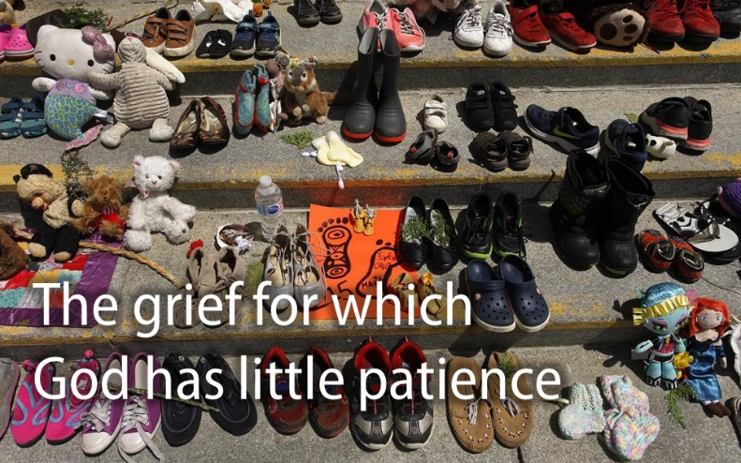
Prayers of the people (using chat to share requests)
Benediction

A Response to #215Children
Our Sunday School has decided to do something concrete to remember and mark the discovery of 215 buried bodies of schoolchildren on the grounds of the Kamloops Residential School. In order to support the ongoing work of Healing and Reconciliation for Indigenous communities in Canada, they will be making a donation to Winnipeg Inner City Mission (WICM) in the amount of $215.00 from their pop can money.
They would like to challenge the people of St. Andrew’s and others to consider making similar donations (of the same amount or whatever the Spirit moves you to give) between now and Canada Day to show our commitment to work towards a better nation for all.
The challenge is also being passed on to other Sunday Schools and churches in our Presbytery to consider making similar responses.
Some indigenous-focussed organizations to consider supporting:
- One of the nine Indigenous ministries in the Presbyterian Church in Canada (including WICM)
- The Woodland Cultural Centre which educates people concerning the closest Residential School to us and its enduring impact
- White Owl Native Ancestry Association which provides counselling and assistance to local indigenous people.
There will be more information on this challenge in the upcoming newsletter.

Next week will be our last week of Sunday School. We will resume online in September. We also hope we can welcome back our young people in person in the fall!

Our Google classroom is posted on our website and Facebook page on Saturday morning.

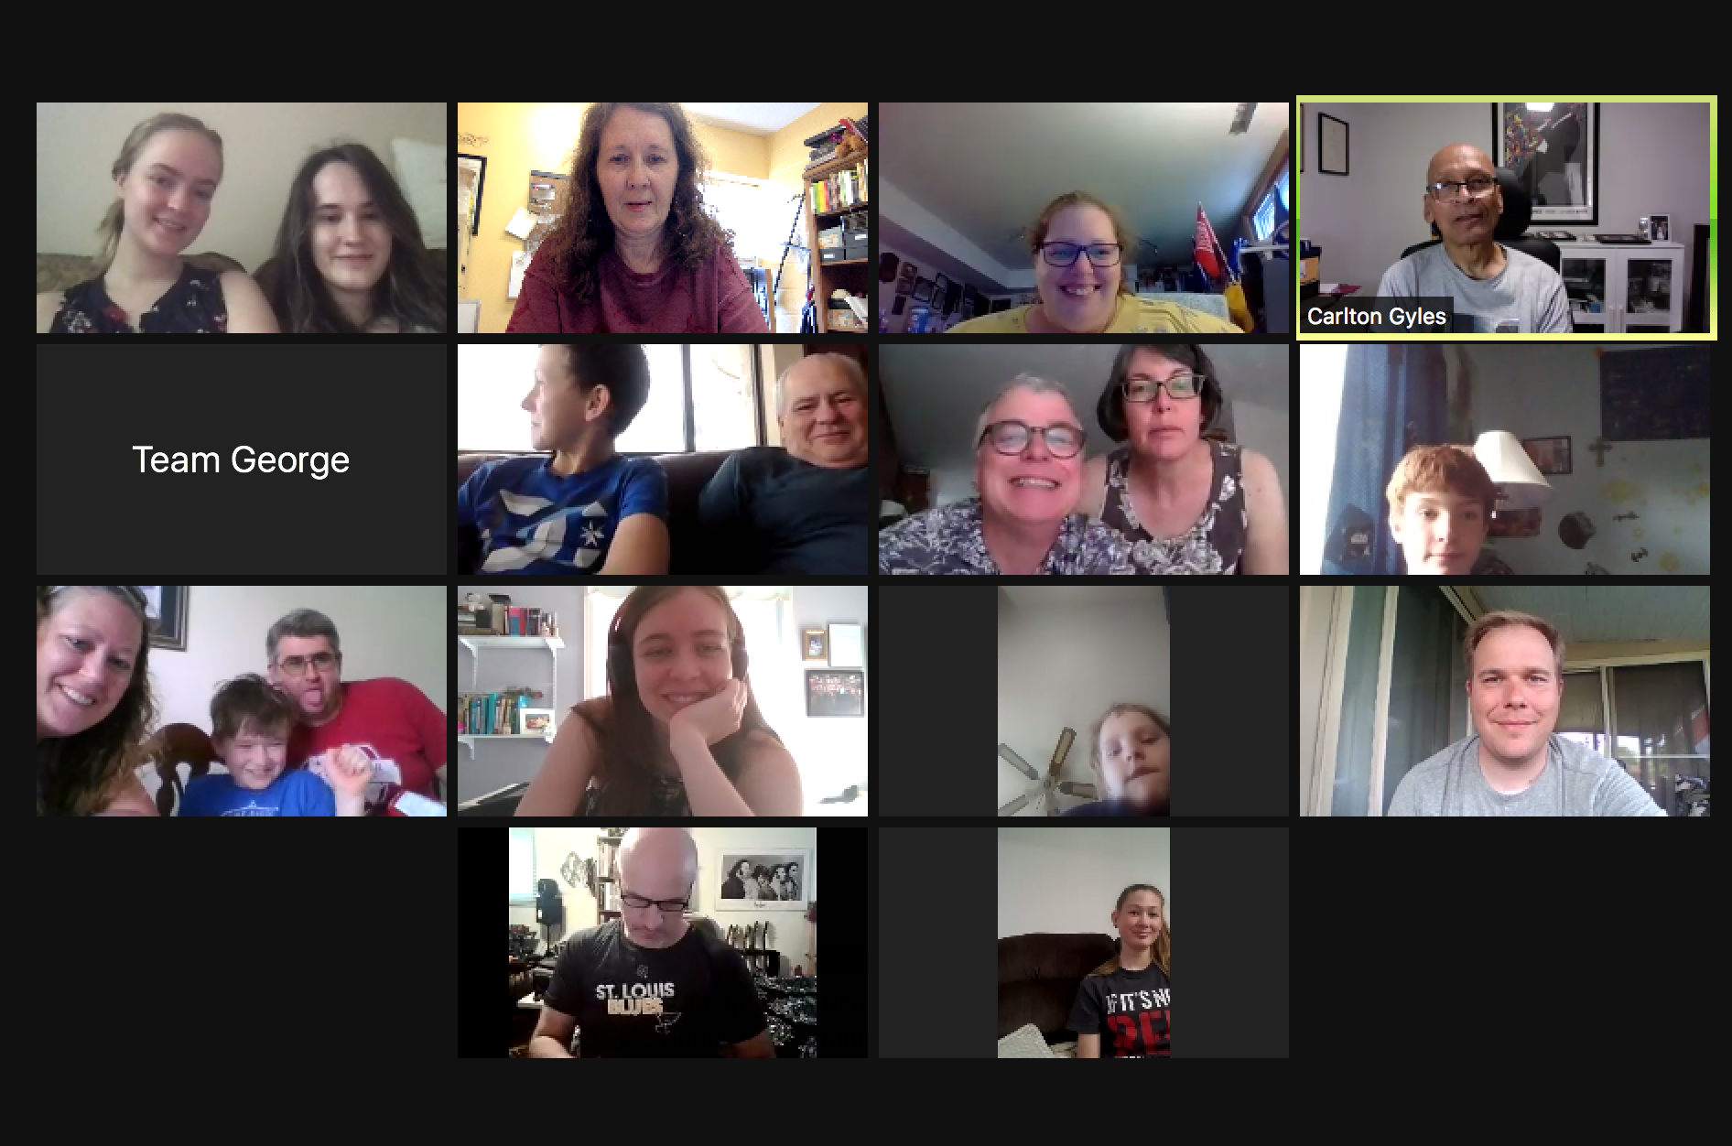
The Youth Group would like to thank everyone who took up their challenge of the online Escape Room last Saturday. We all had a great time. The Youth just managed to beat Scott’s team, with the Marsh Family team very close behind!!
The photo to the left shows a few of our participants!

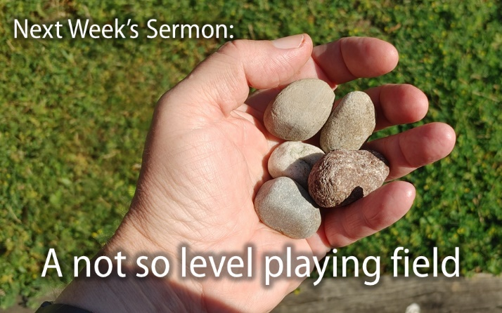
There are some goodies in the mailbox at the church (the one marked “bulletins”) that is free for anyone to pick up. You will find:
- The May/June edition of Today
- The June/July edition of Our Daily Bread
- The spring edition of Presbyterian Connection
- Printed copies of this bulletin each week.
- Printed copies of Scott’s most recent sermon each week.

Other Lectionary Readings

2 Corinthians 5:6-17
⁶ So we are always confident; even though we know that while we are at home in the body we are away from the Lord— ⁷ for we walk by faith, not by sight. ⁸ Yes, we do have confidence, and we would rather be away from the body and at home with the Lord. ⁹ So whether we are at home or away, we make it our aim to please him. ¹⁰ For all of us must appear before the judgement seat of Christ, so that each may receive recompense for what has been done in the body, whether good or evil.
¹¹ Therefore, knowing the fear of the Lord, we try to persuade others; but we ourselves are well known to God, and I hope that we are also well known to your consciences. ¹² We are not commending ourselves to you again, but giving you an opportunity to boast about us, so that you may be able to answer those who boast in outward appearance and not in the heart. ¹³ For if we are beside ourselves, it is for God; if we are in our right mind, it is for you. ¹⁴ For the love of Christ urges us on, because we are convinced that one has died for all; therefore all have died. ¹⁵ And he died for all, so that those who live might live no longer for themselves, but for him who died and was raised for them.
¹⁶ From now on, therefore, we regard no one from a human point of view; even though we once knew Christ from a human point of view, we know him no longer in that way. ¹⁷ So if anyone is in Christ, there is a new creation: everything old has passed away; see, everything has become new!

Mark 4:26-34
²⁶ He also said, ‘The kingdom of God is as if someone would scatter seed on the ground, ²⁷ and would sleep and rise night and day, and the seed would sprout and grow, he does not know how. ²⁸ The earth produces of itself, first the stalk, then the head, then the full grain in the head. ²⁹ But when the grain is ripe, at once he goes in with his sickle, because the harvest has come.’
³⁰ He also said, ‘With what can we compare the kingdom of God, or what parable will we use for it? ³¹ It is like a mustard seed, which, when sown upon the ground, is the smallest of all the seeds on earth; ³² yet when it is sown it grows up and becomes the greatest of all shrubs, and puts forth large branches, so that the birds of the air can make nests in its shade.’
³³ With many such parables he spoke the word to them, as they were able to hear it; ³⁴ he did not speak to them except in parables, but he explained everything in private to his disciples.

We’ve Got Some News
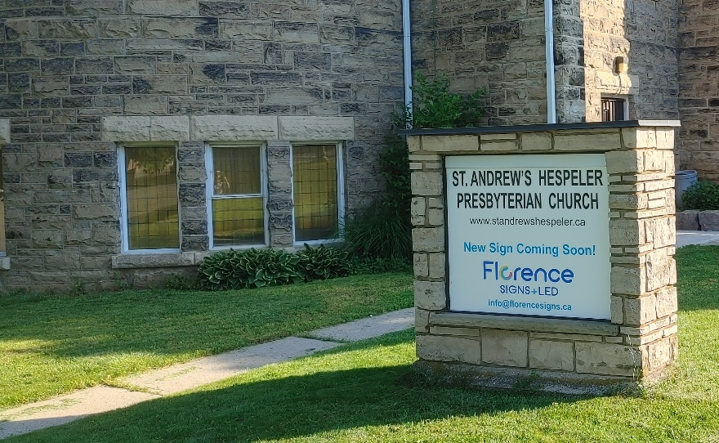
The Session of St. Andrew’s Hespeler met last week (by Zoom) and would like to report that we have been working on a number of matters. Therefore, there will be a newsletter coming out within a few days. Please watch your email and the webpage. Here are some things that we will be reporting on:
- Some grants we have received from the Presbytery of Waterloo-Wellington that are allowing us to take measures to adapt to Covid-19 and post-Covid realities, improve our signage and engagement with the community, and relaunch our ministries.
Watch this space!
Upgrades coming soon!
- Some new initiatives that are being taken by our CE Committee to support our families.
- Thoughts about the future of worship services.

Hope Clothing is in need of children’s summer clothes in all sizes! Deodorant, soap, shampoo, household cleaning products, and laundry detergent are also needed at this time. Hope Clothing is currently open, for clients on Thursdays from 11:00 am – 2:00 pm (please note time change). Donations of summer clothing only will now be accepted on Monday – Wednesday mornings.

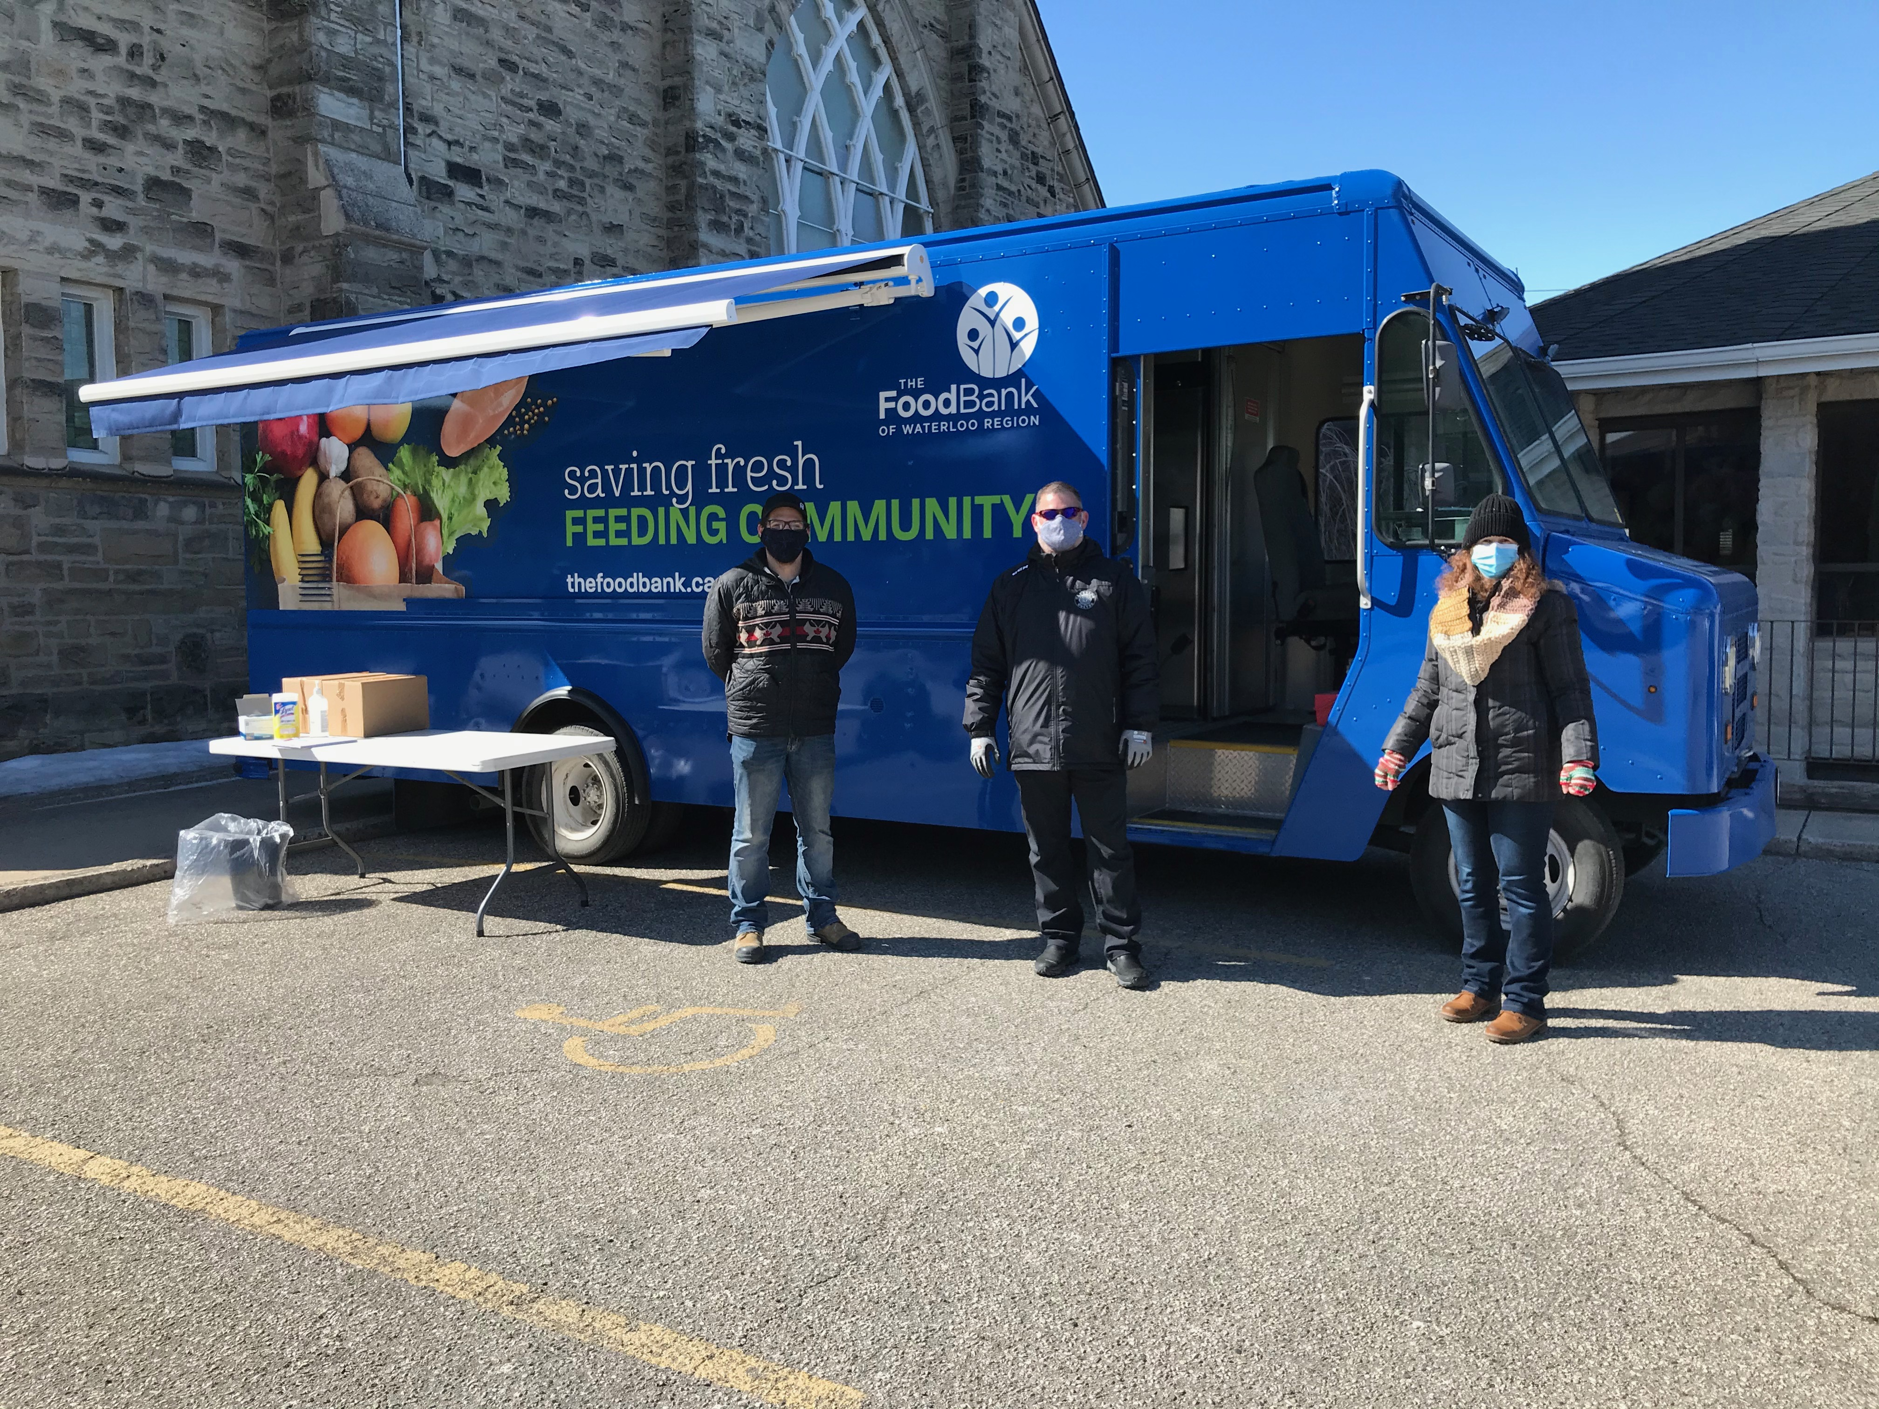
We are still hosting the Waterloo Region Food Bank’s Mobile Pantry on Thursdays from noon – 2:00 pm. As restrictions ease up the delivery of hampers will change back to a new and exciting form of co-op! Details will follow as we know more. Our Hespeler food bank clients are very grateful for the opportunity to have fresh fruit/vegetables and frozen meats available to them.
Mission Moment - June 13, 2021
Meeting the Needs of Families in Beirut
The massive explosion that struck the city of Beirut in August 2020 left many people injured and many homes damaged. Presbyterian World Service & Development (PWS&D) responded to the devastating effects by meeting the needs of vulnerable people in Lebanon. Families received essential supplies, such as food and hygiene items, to sustain them as they started to rebuild. Additionally, PWS&D assisted in restoring homes and schools and provided water and sanitation kits to families, as well as school kits to children.

Prayer Partnership
Sunday, June 13 We pray for people elected to serve in government and that those with power will have wisdom and that those who are wise will have power.
Monday, June 14 We pray for those who work to provide food that strengthens our bodies so that we can love and serve God and one another.
Tuesday, June 15 We pray for vulnerable families affected by COVID-19 in Afghanistan who are receiving food assistance from Presbyterian World Service & Development.
Wednesday, June 16 We pray for the Moderator of the 2021 General Assembly as a new term of pastoral ministry and leadership begins.
Thursday, June 17 We pray for wisdom and discernment as the Rev. Patrick Thegu Mutahi begins his three-year term as Moderator of the Presbyterian Church of East Africa (PCEA) in Kenya.
Friday, June 18 We pray for musicians, singers and artists who add beauty and texture to our worship of God.
Saturday, June 19 We give thanks and pray for teachers who have had to adapt to teaching under new and difficult circumstances.

