St. Andrew’s Hespeler Presbyterian Church
73 Queen Street East,
Cambridge, ON N3C 2A9
519-658-2652
Rev. Scott McAndless: smcandless@standrewshespeler.ca
Email: office@standrewshespeler.ca
Prayer Requests: prayerchain@standrewshespeler.ca
Website: www.standrewshespeler.ca
Office Hours:
The office is currently closed.

St. Andrew’s Hespeler
Presbyterian Church
June 7, 2020
Trinity Sunday
Order of Online Worship for June 7, 2020
We will meet online for as long as people want to stay on at 10 am on Sunday, June 7. The link will be posted on the Website and FaceBook page.
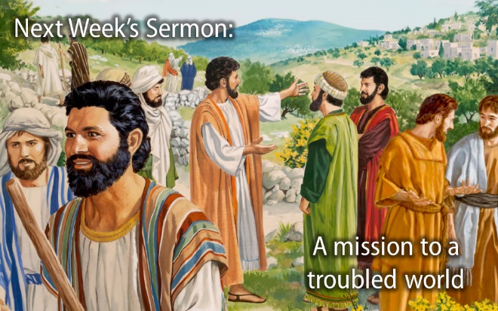
This will be a communion service. Please prepare a glass of juice/wine and a plate bread/biscuit/cracker for each person who would like to participate in taking communion. We will eat and drink at the same time when the minister calls upon us to do so.
Call to worship (Microphones on)
L: O Lord, our Sovereign,
P: How majestic is your name in all the earth!
L: Your glory is above the heavens and surrounds us in the world.
P: And so we come to praise you!
L: When we look at your heavens, the moon and stars, the work of your fingers,
P: Who are we to praise you?
L: Yet you have made us in your image and set us in this world you love.
P: And so we come to worship you and learn to care for your earth.
Prayers of approach and confession

Responsive Psalm 8 (Microphones on)
L: O Lord, our Sovereign,
P: how majestic is your name in all the earth!
L: You have set your glory above the heavens. Out of the mouths of babes and infants
P: you have founded a bulwark because of your foes, to silence the enemy and the avenger.
L: When I look at your heavens, the work of your fingers, the moon and the stars that you have established;
P: what are human beings that you are mindful of them, mortals that you care for them?
L: Yet you have made them a little lower than God,
P: and crowned them with glory and honour.
L: You have given them dominion over the works of your hands;
P: you have put all things under their feet,
L: all sheep and oxen, and also the beasts of the field,
P: the birds of the air, and the fish of the sea, whatever passes along the paths of the seas.
L: O Lord, our Sovereign,
P: how majestic is your name in all the earth!
Ongoing life of the church
Celebration of Generosity
2 Corinthians 13:11-13, Matthew 28:16-20 (see below) – Read by Lynn Craig
Celebration of Communion
Prayer of Great Thanksgiving
L: As grain that was scattered on the hillside was gathered together and made into one loaf, so too, we, scattered at tables in our own homes, are bound together around Christ’s table
and become one.
As grapes grown in the field are gathered together and pressed into wine, so too are we drawn together and pressed by our times to share a common lot and are transformed into Christ’s self-giving love for all.
L: God be with you.
P: And with your spirit.
L: Lift up your hearts
P: We them up to God.
L: Give thanks to God, Blessed Trinity
P: It is right to give God thanks and praise.
L: Praise to you Divine Creator. Thank you for the gift of life, the beauty of nature, the structure the law and your steadfast loving kindness.
Praise to you Divine Redeemer. Thank you for sharing our human existence, from birth through death to everlasting life you have shown us a way worth emulating, bringing healing and hope to those most in need.
Praise to you Divine Sustainer. Thank you for the vision to see beyond the immediate, a calm in the midst of storm, the strength to build an ever-expanding community and the courage to bring about any change necessary within our lives.
Prayer of Consecration
Holy God, pour out your Spirit upon these gifts of grain and grape that they might be for us the presence of the living Christ and pour out your Spirit upon us so that we might taken, blessed,
broken and distributed so that others might know the blessings of living in communion with you and one another. Through Christ, with Christ and in Christ, in the unity of the Holy Spirit,
all glory and honor are yours Almighty God, now and forever.
Amen.
The minister will share the account of the last supper, and we will eat and drink together as one!
Prayers of the people (using chat to share requests)
Benediction *Feel free to chat for a while.
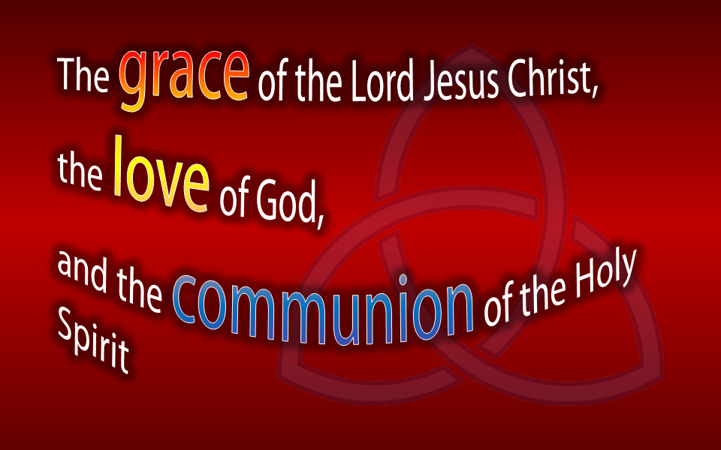
Sermon: Rev. Scott will preach a live sermon over Zoom for those who wish to stay for it. The sermon will also have already been posted on YouTube for streaming whenever you like. The YouTube sermon may have better video and/or audio quality and will feature some graphic illustrations. It will otherwise be the same sermon. The sermon title is:

Financial Update:
The following represents our Year to Date (YTD) April 2020 General Fund performance as compared to the same period last year Last Year:
$ | YTD April 2020 Actual | YTD April 2019 Actual
Receipts | 45,000 | 52,000
Expenses | 84,000 | 89,000
Current Year Surplus/(Deficit) | (39,000) | (37,000)

Items of Note:
- The revenues up to the end of April have come through the normal channels and do not include any government subsidies at this point.
- There are outstanding rental invoices from Dynamo that would have evened out the bottom line with 2019 had we received them.
- In May we applied for the wage subsidy CEWS and we qualified for the first segment of March 15th to April 11th. We did not qualify for the second segment as our revenue in April 2020 needed to be 30% lower than 2019 and it was higher.
- We have also applied for the 10% subsidy for taxes remitted to the Canada Revenue Agency. We will see the resulting subsidy beginning with our May financials.
- We have checked with our insurer to see if we would be covered for any lost revenue. We were informed that because there is no actual peril at the church itself, there would be no coverage for loss of revenue due to COVID-19.
Thank you for your ongoing support to St. Andrews during this crisis. Please pray for our collective responsive to the needs of our General Fund.

Donald Paddock
Stewardship Chairperson

CanadaHelps.org is the online platform that St. Andrew’s Hespeler uses for our online donations. This month, June, for every $1 donated to St. Andrew’s we will earn one chance to win $20, 000. So if you are thinking of trying out online donating, this adds a little bit of fun. You can go to our website: www.standrewshespeler.ca and click on the donate now button at the bottom.

Sunday School news:
Don’t forget to watch the Children’s Message. It is posted on the website by 9:00 am Sunday mornings. Please email me any prayer requests from your children to include in the prayer.

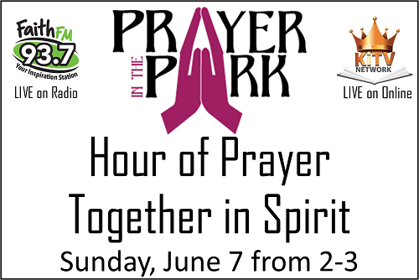
PRAYER IN THE PARK – Today from 2-3pm. We have an amazing opportunity to gather in a new way with one heart and one mind and pray. The need to pray is urgent and we can all pray together without even leaving our homes. Christian leaders from all over Waterloo Region will be leading us as we honour God, humble ourselves, and call to Him for His will to be done through us.

How to Connect: Watch online at https://www.kitvnetwork.com/watch-live. You can find Kingdom Insight TV on all major streaming devices like Roku, Apple TV, Android TV, or Amazon Firestick. You can also install the KiTV app on any smart phone or tablet to watch or cast to your TV. The stream will also be on Facebook.
How to Listen: 93.7 Faith FM or online at http://kitchener.faithfm.org/

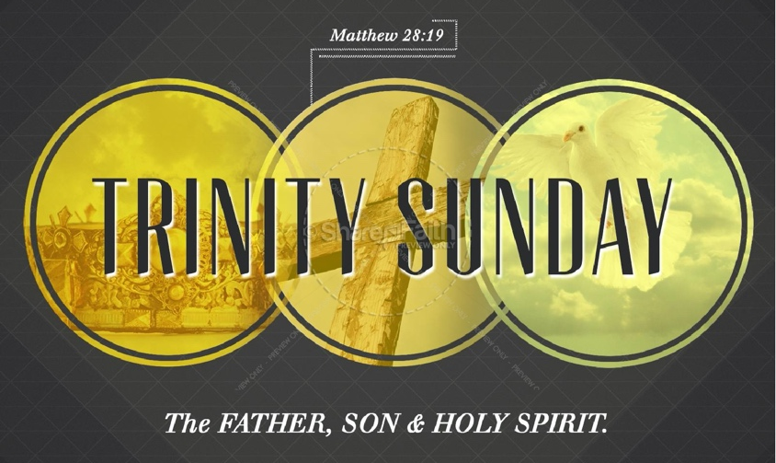

Prayer Partnership

Monday, June 8 We pray for the Rev. Dr. Blair and Vivian Bertrand, and their three children. May their transition to life back in Canada after serving three years in Malawi go well and be filled with many blessings.

Tuesday, June 9 We pray for and give thanks to God for those who would have been commissioners to the 2020 General Assembly, which has been cancelled due to the COVID-19 pandemic.

Wednesday, June 10 We pray for seminary students in their rural and remote summer placements. May this be a time of joy and learning.

Thursday, June 11 During National Indigenous History Month, we give thanks for Indigenous leaders of all ages and nations who are contributing to their communities, and to Canada, and pray for their well-being.

Friday, June 12 We pray for stewardship committees working on plans for fall stewardship campaigns.

Saturday, June 13 We pray for Captain Steven Filyk, who serves as a reserve force military chaplain in Kamloops, B.C., and for his ministry of presence with the diverse communities that are part of the Canadian Armed Forces.

Mission Moment – Sunday, June 7
Enelesi’s Field
When Enelesi Daniel’s house collapsed because of Cyclone Idai, she and her four children were forced to seek shelter outside a school for three months. They lost their entire harvest for the year, along with ducks and chickens. At the camp, Enelesi heard about a Presbyterian World Service & Development (PWS&D) food assistance project and decided to register. Through the project, Enelesi’s family received maize, beans and oil. With the food assistance, the family could eat twice a day, enabling the children to go to school and Enelesi to work her fields. “The project has made a difference because I could actually farm in my own field. I am so grateful because I could do my own farming,” shared Enelesi.
PWS&D responds to natural disasters.
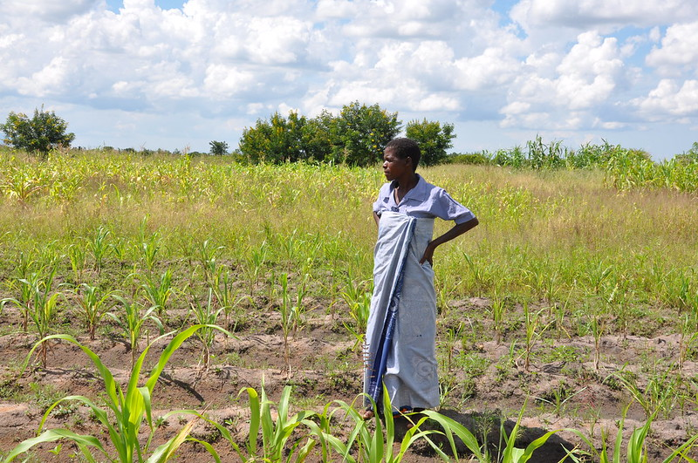

Please Note: All church activities have been suspended until further notice. If you have questions or concerns, or if we can support you in any way, please contact us by calling the church (messages are checked regularly) or email us at office@standrewshespeler.ca. We care about you! You are not alone!

Genesis 1:1–2:4a
In the beginning when God created the heavens and the earth, ² the earth was a formless void and darkness covered the face of the deep, while a wind from God swept over the face of the waters. ³ Then God said, “Let there be light”; and there was light. ⁴ And God saw that the light was good; and God separated the light from the darkness. ⁵ God called the light Day, and the darkness he called Night. And there was evening and there was morning, the first day. ⁶ And God said, “Let there be a dome in the midst of the waters, and let it separate the waters from the waters.” ⁷ So God made the dome and separated the waters that were under the dome from the waters that were above the dome. And it was so. ⁸ God called the dome Sky. And there was evening and there was morning, the second day. ⁹ And God said, “Let the waters under the sky be gathered together into one place, and let the dry land appear.” And it was so. ¹⁰ God called the dry land Earth, and the waters that were gathered together he called Seas. And God saw that it was good. ¹¹ Then God said, “Let the earth put forth vegetation: plants yielding seed, and fruit trees of every kind on earth that bear fruit with the seed in it.” And it was so. ¹² The earth brought forth vegetation: plants yielding seed of every kind, and trees of every kind bearing fruit with the seed in it. And God saw that it was good. ¹³ And there was evening and there was morning, the third day. ¹⁴ And God said, “Let there be lights in the dome of the sky to separate the day from the night; and let them be for signs and for seasons and for days and years, ¹⁵ and let them be lights in the dome of the sky to give light upon the earth.” And it was so. ¹⁶ God made the two great lights– the greater light to rule the day and the lesser light to rule the night – and the stars. ¹⁷ God set them in the dome of the sky to give light upon the earth, ¹⁸ to rule over the day and over the night, and to separate the light from the darkness. And God saw that it was good. ¹⁹ And there was evening and there was morning, the fourth day. ²⁰ And God said, “Let the waters bring forth swarms of living creatures, and let birds fly above the earth across the dome of the sky.” ²¹ So God created the great sea monsters and every living creature that moves, of every kind, with which the waters swarm, and every winged bird of every kind. And God saw that it was good. ²² God blessed them, saying, “Be fruitful and multiply and fill the waters in the seas, and let birds multiply on the earth.” ²³ And there was evening and there was morning, the fifth day. ²⁴ And God said, “Let the earth bring forth living creatures of every kind: cattle and creeping things and wild animals of the earth of every kind.” And it was so. ²⁵ God made the wild animals of the earth of every kind, and the cattle of every kind, and everything that creeps upon the ground of every kind. And God saw that it was good. ²⁶ Then God said, “Let us make humankind in our image, according to our likeness; and let them have dominion over the fish of the sea, and over the birds of the air, and over the cattle, and over all the wild animals of the earth, and over every creeping thing that creeps upon the earth.” ²⁷ So God created humankind in his image, in the image of God he created them; male and female he created them. ²⁸ God blessed them, and God said to them, “Be fruitful and multiply, and fill the earth and subdue it; and have dominion over the fish of the sea and over the birds of the air and over every living thing that moves upon the earth.” ²⁹ God said, “See, I have given you every plant yielding seed that is upon the face of all the earth, and every tree with seed in its fruit; you shall have them for food. ³⁰ And to every beast of the earth, and to every bird of the air, and to everything that creeps on the earth, everything that has the breath of life, I have given every green plant for food.” And it was so. ³¹ God saw everything that he had made, and indeed, it was very good. And there was evening and there was morning, the sixth day.
Thus the heavens and the earth were finished, and all their multitude. ² And on the seventh day God finished the work that he had done, and he rested on the seventh day from all the work that he had done. ³ So God blessed the seventh day and hallowed it, because on it God rested from all the work that he had done in creation. ⁴ These are the generations of the heavens and the earth when they were created.

2 Corinthians 13:11-13
¹¹ Finally, brothers and sisters, farewell. Put things in order, listen to my appeal, agree with one another, live in peace; and the God of love and peace will be with you. ¹² Greet one another with a holy kiss. All the saints greet you. ¹³ The grace of the Lord Jesus Christ, the love of God, and the communion of the Holy Spirit be with all of you.

Matthew 28:16-20
¹⁶ Now the eleven disciples went to Galilee, to the mountain to which Jesus had directed them. ¹⁷ When they saw him, they worshiped him; but some doubted. ¹⁸ And Jesus came and said to them, “All authority in heaven and on earth has been given to me. ¹⁹ Go therefore and make disciples of all nations, baptizing them in the name of the Father and of the Son and of the Holy Spirit, ²⁰ and teaching them to obey everything that I have commanded you. And remember, I am with you always, to the end of the age.
If you were collecting food for the Food Bank for the Sunday School children’s Spring project, please hold onto it until we can safely donate it. Thanks to everyone who participated.

Communion at a time of social distance
It is a good thing and a great blessing to be able to gather and celebrate communion together as a church at any time, and I believe that the ability to do that even during this time of pandemic and social distancing is a great blessing for our church. The session has decided that, so long as we are not able to gather together in the church building, we will plan to celebrate communion a bit more frequently as a symbol of our unity in Christ. Whenever possible, we will hold communion on the first Sunday of each month.
But how is it possible that we are able to celebrate communion in a time of social distancing? It is true that some Christian traditions have decided that celebrations of communion are not possible without physical presence but, fortunately, our Reformed theology allows for that to happen, particularly in extreme situations like we are dealing with these days.
In the Reformed Tradition, there are only a few things that are absolutely necessary for communion to happen. Other things are desirable, but they are not considered to be essential.
In our tradition, the leadership have a member of the clergy, a minister of word and sacrament, is necessary. The minister is necessary because she or he has been ordained through the laying on of hands by the church and maintains the connection with the historic leadership of the church. In order for communion to happen, the people need to be able to hear or see the minister invoking the Holy Spirit, speaking the words and breaking the bread.
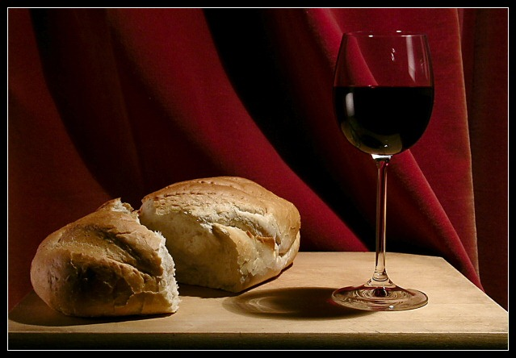
The other thing that is necessary for communion to happen is God’s Holy Spirit. The minister calls on the Holy Spirit to be poured out upon the communion elements and upon the people of God. This is the actual special ingredient that turns an ordinary meal into a heavenly feast.
There is actually nothing else that is absolutely essential. The elements of bread and wine are important, but it is permissible that they take various forms, which is why we do not hesitate to substitute grape juice or gluten-free breads, for example, whenever appropriate. The actual physical presence of God’s people together is obviously important and to be desired, but it is not absolutely necessary because we believe that God’s Holy Spirit and the action of the Holy Spirit is limited by neither time nor space. This means that it is possible for us to be gathered virtually in our separate homes and yet still to unite around one common communion table.
I hope that this sign and symbol of our unity in Christ is meaningful to you during these very trying days.

