St. Andrew’s Hespeler
Presbyterian Church
May 3, 2020
4th Sunday of Easter
St. Andrew’s Hespeler Presbyterian Church
73 Queen Street East,
Cambridge, ON N3C 2A9
519-658-2652
Rev. Scott McAndless: smcandless@standrewshespeler.ca
Email: office@standrewshespeler.ca
Prayer Requests: prayerchain@standrewshespeler.ca
Website: www.standrewshespeler.ca
Office Hours:
The office is currently closed.
Order of Online Worship for May 3, 2020
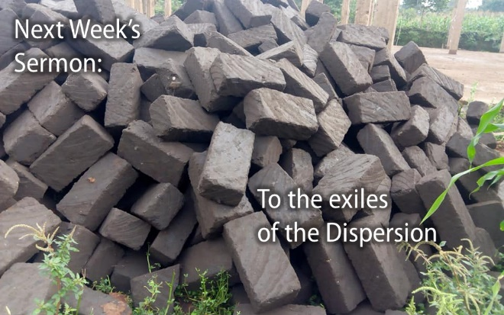
We will meet online for as long as people want to stay on at 10 am on Sunday, May 3. The link will be posted on the Website and FaceBook page.
Call to worship (Microphones on)
L: Let us worship God in the name of Jesus Christ, the good shepherd,
P: who offers us abundant life.
L: Let us worship God in the name of the One who leads us by still waters,
P: and restores our souls.
L: Let us worship God in the name of the One who prepares a banquet for us,
P: and fills our cups to overflowing.
Prayers of confession

Responsive Psalm 23 (Microphones on)
L: The Lord is my shepherd,
P: I shall not want.
L: He makes me lie down in green pastures;
P: he leads me beside still waters; he restores my soul.
L: He leads me in right paths for his name’s sake.
P: Even though I walk through the darkest valley, I fear no evil;
L: for you are with me;
P: your rod and your staff — they comfort me.
L: You prepare a table before me in the presence of my enemies;
P: you anoint my head with oil; my cup overflows.
L: Surely goodness and mercy shall follow me all the days of my life,
P: and I shall dwell in the house of the Lord my whole life long.
Ongoing life of the church
Celebration of our Generosity
John 10:1-15 (see below)
Prayers of the people (using chat to share requests)
Benediction *Feel free to chat for a while.
Sermon: Rev. Scott will preach a live sermon over Zoom for those who wish to stay for it. The sermon will also have already been posted on YouTube for streaming whenever you like. The YouTube sermon may have better video and/or audio quality and will feature some graphic illustrations. It will otherwise be the same sermon. The sermon title is:
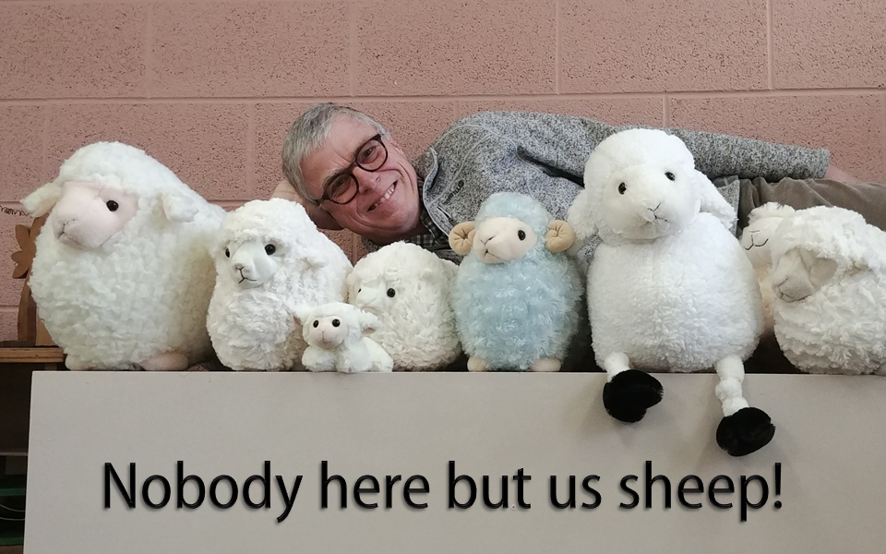
The sympathy of the congregation is extended to:
Donald & Laurie Paddock & family and Rick & Debbie Paddock & family on the recent death of Donald’s & Rick’s uncle, Stewart Paddock. Please keep the Paddock family in your prayers.
Sandra Dobbie & family, on the recent death of her brother, John Aikens. Please Sandra & her family in your prayers.

Great is Thy Faithfulness
Looking for encouraging music during these uncertain times?

https://www.youtube.com/watch?v=37wV6D49iEY https://www.youtube.com/watch?v=sIaT8Jl2zpI

The Session of St. Andrew’s has decided to participate in GivingTuesday, now on Tuesday, May 5th. This is a one day celebration of generosity.

These are, indeed, strange and new times for all of us. We realize that there is so much uncertainty for many people. Many people are without jobs, some are working from home, some are working from home AND trying to home school their children. We have risen to the challenges given to us by self isolation. We are trying to conquer our stress and anxiety – it’s not easy. Without a doubt, life has changed for everyone.

On Tuesday, May 5th we will be joining together with GivingTuesday Canada to focus on not only monetary donations, but also the many generous acts of kindness and support that we have been hearing about. Some of you have been sewing hospital gowns for our local non-profits and doctor’s offices, some have been sewing face masks for Cambridge Memorial Hospital. Others are knitting/crocheting dish clothes for Crieff Hills Conference Centre (for use in individual cabins/houses). People have donated their fabric and elastic to those sewing face masks and gowns. People have opened their doors to a knock, only to find a bag of groceries sitting there! We are making phone calls to people who are living on their own or keeping in touch in other ways. There are so many ways that you have been GIVING!

While many families have been directly affected by Covid-19, we still have so much for which to be grateful. Did you know practicing gratitude really can help us to reduce our stress and anxiety? It helps us to focus on the good. We are the Easter people. Now is our time to follow in Jesus’ footsteps, to serve one another in his name and to lift each other up in prayer.

Please send Joni an email (jsmith@standrewshespeler.ca) or message about what you have been doing to practice generosity in the past month. Send me photos! Tell me your story. Tell me how you’ve been a recipient of generosity and how it made you feel. Let’s flood our FaceBook page and other social media with our gratitude.

(if you would like to donate online, please go to our website [www.standrewshespeler.ca] and click on the green “Donate Online” button at the bottom left corner of the home page)

Sunday School news:
As some of you already know, I have been recording a weekly Children’s Message. This is a story from Children & Worship, bible reading with the lit Christ candle and prayer. This is posted on our website each Sunday morning by 9:00 am.
In the Divine Detectives class our prayer is very important. I would like to include our personal prayers in the recording, if you would like. You can help me by emailing me your prayer request by Thursday of each week. I will include your prayers in our prayer together, with your first name only.
I will stop by the church soon to pick up our prayer journal so that we can also record our prayers with the others.
Thank you!
Blessings,
Joni
jsmith@standrewshespeler.ca
Prayer Partnership

Sunday, May 3 We pray for our mission partners in Canada and around the world, supported through gifts to Presbyterians Sharing.
Monday, May 4 We pray for candidates for ministry and for guidance counsellors who will spend time engaged in dialogue about calling and discernment during Guidance Conference.
Tuesday, May 5 We pray for the Governing Board of Knox College as they oversee the work of the college and plan for its future.
Wednesday, May 6 We pray for those preparing for Vacation Bible Schools and day camps this summer. Ask that God blesses them with an abundance of resources, volunteers and children.
Thursday, May 7 We give thanks for leaders of the National Indigenous Ministry Council. We pray your blessing upon them as they lead the Indigenous Christian Prayer Retreat.
Friday, May 8 We pray for those in the Order of Diaconal Ministries who are called to serve the church in Christian education, pastoral care and social ministries.
Saturday, May 9 Pray that the members of the Committee on Church Doctrine are guided by the Holy Spirit to put aside theological differences and work together to glorify God and be an example of what it means to serve Christ in unity for the church.

Please Note: All church activities have been suspended until further notice. If you have questions or concerns, or if we can support you in any way, please contact us by calling the church (messages are checked regularly) or email us at office@standrewshespeler.ca. We care about you! You are not alone!
May 3: Making a new home after fleeing Syria
When the war in Syria intensified in 2012, many families were driven from their homes. The bombing of Garib’s family apartment left him clutching his two-day old son as they ran “a race for their lives.” In his family’s new home in Lebanon, employers are hesitant to hire refugees, so every day is a struggle. Garib’s family misses the things that made Syria home: “My four-year-old remembers that he used to have a bicycle back in Syria. That’s not an option for him here.” Through a PWS&D-supported program, Garib, his wife and children, and his extended family are able to access food vouchers, milk and diapers, as well as psychosocial care. Grateful for the support they receive, Garib said, “I think the church does this because Christianity is love.”
PWS&D shares the love of Christ through food assistance.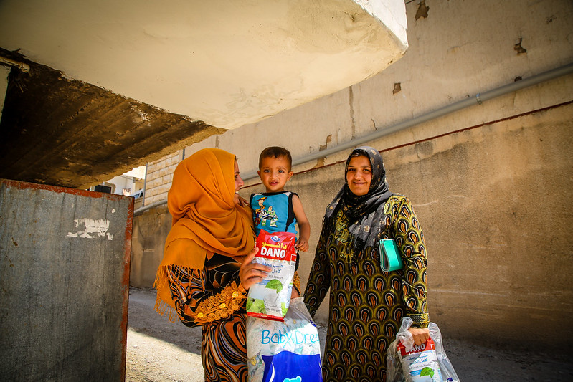

The Revised Common Lectionary Readings for the Week of May 3, 2020

Acts 2:42-47
⁴² They devoted themselves to the apostles’ teaching and fellowship, to the breaking of bread and the prayers. ⁴³ Awe came upon everyone, because many wonders and signs were being done by the apostles. ⁴⁴ All who believed were together and had all things in common; ⁴⁵ they would sell their possessions and goods and distribute the proceeds to all, as any had need. ⁴⁶ Day by day, as they spent much time together in the temple, they broke bread at home and ate their food with glad and generous hearts, ⁴⁷ praising God and having the goodwill of all the people. And day by day the Lord added to their number those who were being saved.

1 Peter 2:19-25
¹⁹ For it is a credit to you if, being aware of God, you endure pain while suffering unjustly. ²⁰ If you endure when you are beaten for doing wrong, what credit is that? But if you endure when you do right and suffer for it, you have God’s approval. ²¹ For to this you have been called, because Christ also suffered for you, leaving you an example, so that you should follow in his steps. ²² “He committed no sin, and no deceit was found in his mouth.” ²³ When he was abused, he did not return abuse; when he suffered, he did not threaten; but he entrusted himself to the one who judges justly. ²⁴ He himself bore our sins in his body on the cross, so that, free from sins, we

might live for righteousness; by his wounds you have been healed. ²⁵ For you were going astray like sheep, but now you have returned to the shepherd and guardian of your souls.

John 10:1-15
“Very truly, I tell you, anyone who does not enter the sheepfold by the gate but climbs in by another way is a thief and a bandit. ² The one who enters by the gate is the shepherd of the sheep. ³ The gatekeeper opens the gate for him, and the sheep hear his voice. He calls his own sheep by name and leads them out. ⁴ When he has brought out all his own, he goes ahead of them, and the sheep follow him because they know his voice. ⁵ They will not follow a stranger, but they will run from him because they do not know the voice of strangers.”
⁶ Jesus used this figure of speech with them, but they did not understand what he was saying to them. ⁷ So again Jesus said to them, “Very truly, I tell you, I am the gate for the sheep. ⁸ All who came before me are thieves and bandits; but the sheep did not listen to them. ⁹ I am the gate. Whoever enters by me will be saved, and will come in and go out and find pasture. ¹⁰ The thief comes only to steal and kill and destroy. I came that they may have life, and have it abundantly.
¹¹ “I am the good shepherd. The good shepherd lays down his life for the sheep. ¹² The hired hand, who is not the shepherd and does not own the sheep, sees the wolf coming and leaves the sheep and runs away – and the wolf snatches them and scatters them. ¹³ The hired hand runs away because a hired hand does not care for the sheep. ¹⁴ I am the good shepherd. I know my own and my own know me, ¹⁵ just as the Father knows me and I know the Father. And I lay down my life for the sheep.

Here’s our next Sunday School project:
Do you know that there are many people in our community who do not have enough food?. Now, more than ever, there are people who can’t afford to buy food for their family. The Cambridge Self-Help Foodbank needs help serving the growing needs of people in our community. At this time they can only take money (to be safe)
donations.

Here’s your project:
*start a journal and at least once a week, write out or draw what you are grateful for. We have much to be grateful for! If you would like to share with me (jsmith@standrewshespeler.ca) I would love to post on social media so that we can be an example to other people!

*start a food basket or box and once a week put an item of food in it. When we can safely get back together, at church,
we will bring in all of our baskets of food and donate them to the Cambridge Self-Help FoodBank.

*challenge your friends, cousins, neighbours to do the same
and donate the collected food to the food bank in their own
community.

