St. Andrew’s Hespeler Presbyterian Church
73 Queen Street East,
Cambridge, ON N3C 2A9
519-658-2652
Rev. Scott McAndless: smcandless@standrewshespeler.ca
Email: office@standrewshespeler.ca
Prayer Requests: prayerchain@standrewshespeler.ca
Website: www.standrewshespeler.ca
Office Hours:
The office is currently closed.

St. Andrew’s Hespeler
Presbyterian Church
April 26, 2020
3rd Sunday of Easter
Order of Online Worship for April 26, 2020
We will meet online for as long as people want to stay on at 10 am on Sunday, April 26. The link will be posted on the Website and FaceBook page.
Call to worship (Microphones on)
L: Where shattered hearts are made whole, where wounded souls are healed, where life is stronger than death:
P: there, the stone has been rolled away.
L: Where the lonely become our friends, where a stranger is welcomed home, where hope is stronger than despair,
P: there, we find Jesus walking.
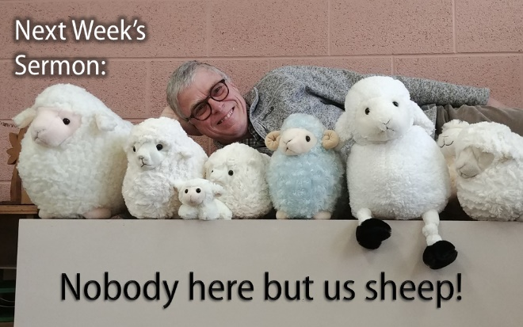
L: Where closed wallets are opened, where the anxious find serenity, where love is stronger than hate:
P: there, Jesus is opening our eyes.
L: The stone has been rolled away! Jesus is our companion on the journey! Our eyes are opened to the needs of others!
P: Alleluia! Christ is risen! Alleluia! Christ is with us!
Prayers of confession

Responsive Psalm 116:1-4, 12-19 (Microphones on)

L: I love the Lord, because he has heard my voice and my supplications.

P: Because he inclined his ear to me, therefore I will call on him as long as I live.

L: The snares of death encompassed me; the pangs of Sheol laid hold on me; I suffered distress and anguish.

P: Then I called on the name of the Lord: “O Lord, I pray, save my life!”
L: What shall I return to the Lord for all his bounty to me?
P: I will lift up the cup of salvation and call on the name of the Lord, I will pay my vows to the Lord in the presence of all his people.
L: Precious in the sight of the Lord is the death of his faithful ones. O Lord, I am your servant; I am your servant, the child of your serving girl. You have loosed my bonds.
P: I will offer to you a thanksgiving sacrifice and call on the name of the Lord. I will pay my vows to the Lord in the presence of all his people, in the courts of the house of the Lord, in your midst, O Jerusalem. Praise the Lord!
Ongoing life of the church
Luke 24:13-35 (see below)
Celebration of our Generosity
Prayers of the people (using chat to share requests)
Benediction *Feel free to chat for a while.
Sermon: Rev. Scott will preach a live sermon over Zoom for those who wish to stay for it. The sermon will also have already been posted on YouTube for streaming whenever you like. The YouTube sermon may have better video and/or audio quality and will feature some graphic illustrations. It will otherwise be the same sermon. The sermon title is:
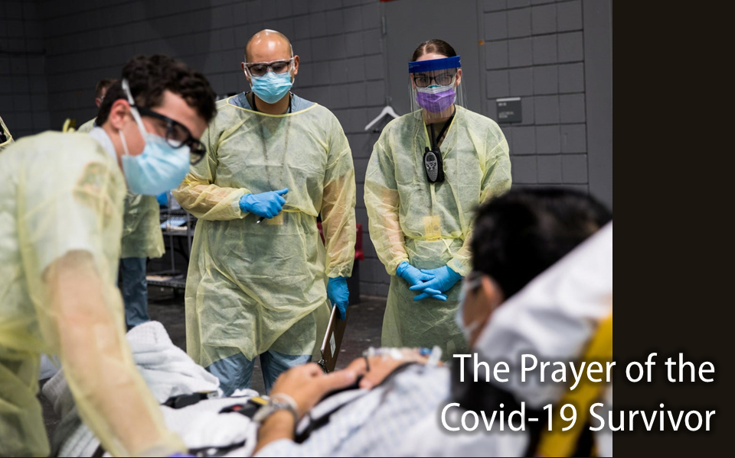
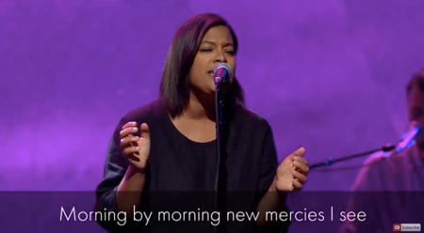
Great is Thy Faithfulness
Looking for encouraging music during these uncertain times?

https://www.youtube.com/watch?v=vAz9C100O5A https://www.youtube.com/watch?v=2eQ1oal44wU

The Session of St. Andrew's has decided to participate in GivingTuesday, now on Tuesday, May 5th. This is a one day celebration of generosity.

These are, indeed, strange and new times for all of us. We realize that there is so much uncertainty for many people. Many people are without jobs, some are working from home, some are working from home AND trying to home school their children. We have risen to the challenges given to us by self isolation. We are trying to conquer our stress and anxiety - it's not easy. Without a doubt, life has changed for everyone.

On Tuesday, May 5th we will be joining together with GivingTuesday Canada to focus on not only monetary donations, but also the many generous acts of kindness and support that we have been hearing about. Some of you have been sewing hospital gowns for our local non-profits and doctor's offices, some have been sewing face masks for Cambridge Memorial Hospital. Others are knitting/crocheting dish clothes for Crieff Hills Conference Centre (for use in individual cabins/houses). People have donated their fabric and elastic to those sewing face masks and gowns. People have opened their doors to a knock, only to find a bag of groceries sitting there! We are making phone calls to people who are living on their own or keeping in touch in other ways. There are so many ways that you have been GIVING!

While many families have been directly affected by Covid-19, we still have so much for which to be grateful. Did you know practicing gratitude really can help us to reduce our stress and anxiety? It helps us to focus on the good. We are the Easter people. Now is our time to follow in Jesus' footsteps, to serve one another in his name and to lift each other up in prayer.

Please send Joni an email (jsmith@standrewshespeler.ca) or message about what you have been doing to practice generosity in the past month. Send me photos! Tell me your story. Tell me how you've been a recipient of generosity and how it made you feel. Let's flood our FaceBook page and other social media with our gratitude.

(if you would like to donate online, please go to our website [www.standrewshespeler.ca] and click on the green "Donate Online" button at the bottom left corner of the home page)
Prayer Partnership

Sunday, April 26 (Mission Awareness Sunday) We pray for all local Women’s Missionary Society groups who will be leading worship for Mission Awareness Sunday. May their words inspire all to be involved in mission.

Monday, April 27 We pray for the Rev. Roger MacPhee who serves as Convener of the Ministry Committee for the Presbytery of Prince Edward Island.

Tuesday, April 28 We pray for the renewal of soil around the world so that all species can flourish free from wants.

Wednesday, April 29 Give thanks for the children in our church schools and youth groups, and for the leaders who love them, care for them and teach them.

Thursday, April 30 We pray for the members of the Committee on Education and Reception as they meet this week with the candidates and ministers who have applied to be received into the PCC.

Friday, May 1 We pray for all the Presbyterian camps as they prepare for the campers who will be gathering this summer.

Saturday, May 2 (Asian Heritage Month) We give thanks for the gifts and accomplishments of Asian people in Canada. May we come together to celebrate Asian cultures and seek out parts of our history that often go untold.

Please Note: All church activities have been suspended until further notice. If you have questions or concerns, or if we can support you in any way, please contact us by calling the church (messages are checked regularly) or email us at office@standrewshespeler.ca. We care about you! You are not alone!
April 26: Spanish Outreach Ministry
In summer of 2019, University Presbyterian Church in North York, Ont., launched a new worshipping community for Spanish-speakers. The ministry’s leader, Julio, started by connecting with members of his own Hispanic community who are not attending church. With a team from his church, Julio has begun establishing small discipleship groups and outreach initiatives, including taco nights and a soccer league for children. Please pray for University Presbyterian Church, Julio, and leaders who are stepping out in faith to plant new ministries.
Presbyterians Sharing is planting new ministries.

The Revised Common Lectionary Readings for the Week of April 26, 2020

Acts 2:14a, 22-32
¹⁴ But Peter, standing with the eleven, raised his voice and addressed them,
²² “You that are Israelites, listen to what I have to say: Jesus of Nazareth, a man attested to you by God with deeds of power, wonders, and signs that God did through him among you, as you yourselves know – ²³ this man, handed over to you according to the definite plan and foreknowledge of God, you crucified and killed by the hands of those outside the law. ²⁴ But God raised him up, having freed him from death, because it was impossible for him to be held in its power. ²⁵ For David says concerning him,
‘I saw the Lord always before me, for he is at my right hand so that I will not be shaken; ²⁶ therefore my heart was glad, and my tongue rejoiced; moreover my flesh will live in hope. ²⁷ For you will not abandon my soul to Hades, or let your Holy One experience corruption. ²⁸ You have made known to me the ways of life; you will make me full of gladness with your presence.’
²⁹ “Fellow Israelites, I may say to you confidently of our ancestor David that he both died and was buried, and his tomb is with us to this day. ³⁰ Since he was a prophet, he knew that God had sworn with an oath to him that he would put one of his descendants on his throne. ³¹ Foreseeing this, David spoke of the resurrection of the Messiah, saying, ‘He was not abandoned to Hades, nor did his flesh experience

corruption.’ ³² This Jesus God raised up, and of that all of us are witnesses.

1 Peter 1:17-23
¹⁷ If you invoke as Father the one who judges all people impartially according to their deeds, live in reverent fear during the time of your exile. ¹⁸ You know that you were ransomed from the futile ways inherited from your ancestors, not with perishable things like silver or gold, ¹⁹ but with the precious blood of Christ, like that of a lamb without defect or blemish. ²⁰ He was destined before the foundation of the world, but was revealed at the end of the ages for your sake. ²¹ Through him you have come to trust in God, who raised him from the dead and gave him glory, so that your faith and hope are set on God. ²² Now that you have purified your souls by your obedience to the truth so that you have genuine mutual love, love one another deeply from the heart. ²³ You have been born anew, not of perishable but of imperishable seed, through the living and enduring word of God.

Luke 24:13-35
¹³ Now on that same day two of them were going to a village called Emmaus, about seven miles from Jerusalem, ¹⁴ and talking with each other about all these things that had happened. ¹⁵ While they were talking and discussing, Jesus himself came near and went with them, ¹⁶ but their eyes were kept from recognizing him. ¹⁷ And he said to them, “What are you discussing with each other while you walk along?” They stood still, looking sad. ¹⁸ Then one of them, whose name was Cleopas, answered him, “Are you the only stranger in Jerusalem who does not know the things that have taken place there in these days?” ¹⁹ He asked them, “What things?” They replied, “The things about Jesus of Nazareth, who was a prophet mighty in deed and word before God and all the people, ²⁰ and how our chief priests and leaders handed him over to be condemned to death and crucified him. ²¹ But we had hoped that he was the one to redeem Israel. Yes, and besides all this, it is now the third day since these things took place. ²² Moreover, some women of our group astounded us. They were at the tomb early this morning, ²³ and when they did not find his body there, they came back and told us that they had indeed seen a vision of angels who said that he was alive. ²⁴ Some of those who were with us went to the tomb and found it just as the women had said; but they did not see him.” ²⁵ Then he said to them, “Oh, how foolish you are, and how slow of heart to believe all that the prophets have declared! ²⁶ Was it not necessary that the Messiah should suffer these things and then enter into his glory?” ²⁷ Then beginning with Moses and all the prophets, he interpreted to them the things about himself in all the scriptures.
²⁸ As they came near the village to which they were going, he walked ahead as if he were going on. ²⁹ But they urged him strongly, saying, “Stay with us, because it is almost evening and the day is now nearly over.” So he went in to stay with them. ³⁰ When he was at the table with them, he took bread, blessed and broke it, and gave it to them. ³¹ Then their eyes were opened, and they recognized him; and he vanished from their sight. ³² They said to each other, “Were not our hearts burning within us while he was talking to us on the road, while he was opening the scriptures to us?” ³³ That same hour they got up and returned to Jerusalem; and they found the eleven and their companions gathered together. ³⁴ They were saying, “The Lord has risen indeed, and he has appeared to Simon!” ³⁵ Then they told what had happened on the road, and how he had been made known to them in the breaking of the bread.

Here's our next Sunday School project:
Do you know that there are many people in our community who do not have enough food?. Now, more than ever, there are people who can't afford to buy food for their family. The Cambridge Self-Help Foodbank needs help serving the growing needs of people in our community. At this time they can only take money (to be safe)
donations.

Here's your project:
*start a journal and at least once a week, write out or draw what you are grateful for. We have much to be grateful for! If you would like to share with me (jsmith@standrewshespeler.ca) I would love to post on social media so that we can be an example to other people!

*start a food basket or box and once a week put an item of food in it. When we can safely get back together, at church,
we will bring in all of our baskets of food and donate them to the Cambridge Self-Help FoodBank.

*challenge your friends, cousins, neighbours to do the same
and donate the collected food to the food bank in their own
community.

